Sales Analysis:
Table: Sales
CREATE TABLE Sales ( sale_id INT PRIMARY KEY, customer_name VARCHAR(50), city VARCHAR(50), product_name VARCHAR(50), category VARCHAR(50), quantity INT, price DECIMAL(10,2), sale_date DATE );
INSERT INTO Sales VALUES

(1, 'Ravi', 'Bangalore', 'Laptop', 'Electronics', 1, 60000, '2023-06-01'), (2, 'Priya', 'Chennai', 'Mobile', 'Electronics', 2, 20000, '2023-06-03'), (3, 'Amit', 'Delhi', 'Headphones', 'Accessories', 3, 2000, '2023-06-05'), (4, 'Neha', 'Mumbai', 'Chair', 'Furniture', 2, 5000, '2023-06-07'), (5, 'Ravi', 'Bangalore', 'Mobile', 'Electronics', 1, 20000, '2023-06-10'), (6, 'Priya', 'Chennai', 'Laptop', 'Electronics', 1, 60000, '2023-06-12'), (7, 'Amit', 'Delhi', 'Chair', 'Furniture', 4, 5000, '2023-06-15'), (8, 'Neha', 'Mumbai', 'Headphones', 'Accessories', 2, 2000, '2023-06-18');

2. Display only customer names and cities.
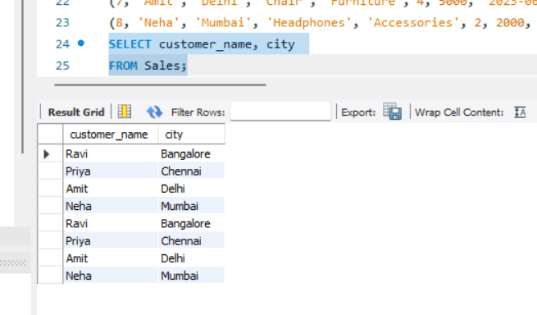

3. Show product name and price.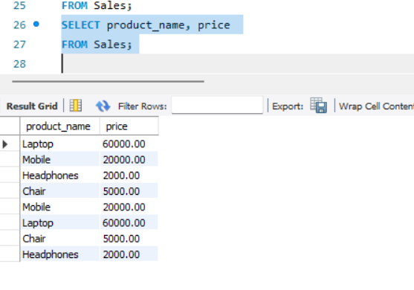

4. Show all sales where city is 'Bangalore'.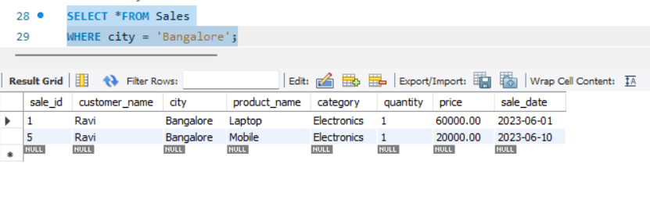

5. Find all products in 'Electronics' category.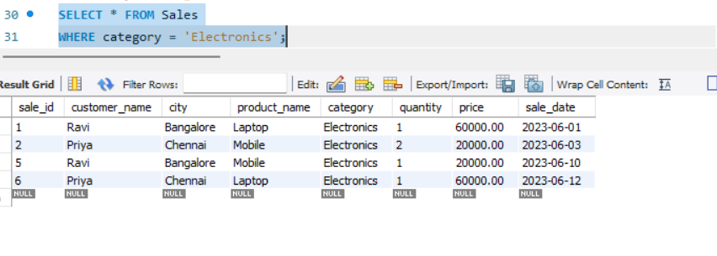

6. Show sales where price is greater than 10,000.
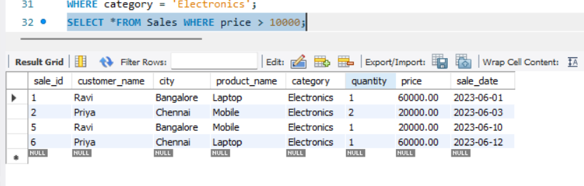

7. Display sales where quantity is more than 2.

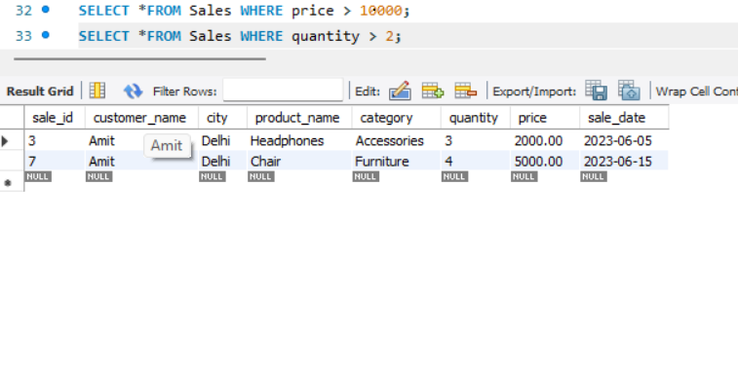

8. Show all sales sorted by price (low to high).
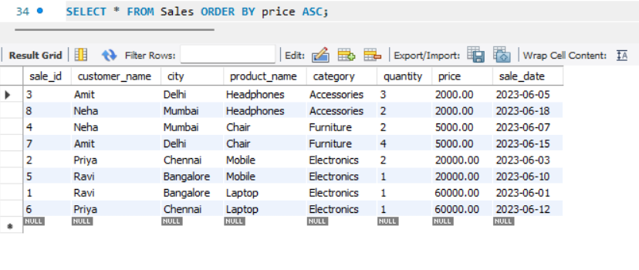

9. Display sales sorted by quantity (high to low).
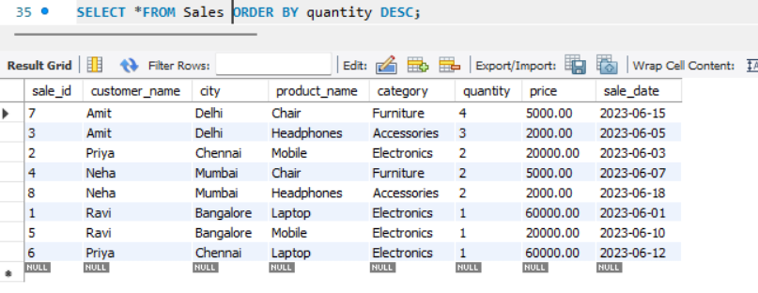

10. Show unique cities.

